Group symbol: 2
Team: 1

Project title: ListItUp

Team members (filled by PM, Team Leader):
No | Name | Surname | Student ID | Role
1 | Carmelo | Romero Pérez | 293936 | PM, Team Leader
2 | Álvaro | Puebla Ruisánchez | 293867 | Team member
3 | Carmen | Gutiérrez Sánchez | 293906 | Team member
4 | David | Sosa Domínguez | 293885 | Team member
5 | Diego | García Agrelo | 293939 | Team member
6 | Miryam | Merchán León | 293907 | Team member

- Requirements specification (S2)
  - Functional Requirements Specification
In this section, provide the table for functional requirements, including symbol, type (e.g. business logic, user interface, data exchange, etc.) description, significance (MoSCoW) and source (Stakeholder).
The requirements are structured around five domains: user account management, list and item management, social interaction, content discovery, and platform administration. Must-have requirements constitute the minimum viable set for the pilot release; Should-have requirements extend the experience without blocking the first release.

MVP Functional Requirements: core features (Must = critical, Should/Could = less critical)
Symbol | Type | Description | Significance | Source
FR1 | Business Logic | Create a List: Authenticated users can create and publish a curated list with a title, description, cover photo, and public/private visibility. | Must | E1 - Casual Users  E2 - Verified Creators
FR2 | Business Logic / Data Management | Manage Items: Users can add, edit, reorder, and delete items within a list. Each item supports a title, short description, external URL, and optional photo. | Must | E1 - Casual Users  E2 - Verified Creators
FR3 | Business Logic | Discovery and Search: The platform offers a category-based feed of public lists and a keyword search filterable by category and sortable by relevance or recency. | Must | E1 - Casual Users  E2 - Verified Creators
FR4 | Business Logic / Social Interaction | Social Interactions: Users can follow others, like lists, post comments, and save lists to a personal collection. | Must | E1 - Casual Users  E2 - Verified Creators
FR5 | Business Logic / Moderation | Reporting and Moderation: Users can report lists, items, or comments. Administrators can review reports and delete any content from a dedicated panel. | Must | E1 - Casual Users  E3 - Administrators
FR6 | Data Exchange / Notifications | Notifications: The system sends in-app notifications for likes, comments, and new posts from followed creators. Key events also trigger email notifications via a third-party provider. | Should | E1 - Casual Users  E2 - Verified Creators  E4 - API Providers
FR7 | User Interface / Analytics | Creator Analytics: Verified creators have access to a private dashboard showing per-list statistics: views, saves, likes, and link clicks, updated daily. | Should | E2 - Verified Creators

  - Non-Functional Requirements
In this section provide the table for non-functional requirements that includes symbol, type (e.g., efficiency, standards, constraints, etc.), description, significance (MoSCoW) for the project, source (Stakeholder). Each requirement should also have specified a verification method - a description of a confirmation method whether a requirement has been fulfilled or not in the most measurable and objective way.
Key non-functional requirements derive from the project’s technological, legal and organizational context. These include security (campus SSO, encryption), performance and scalability, accessibility and audit compliance, and deployment constraints. Metrics and verification methods are specified to ensure measurable quality.

Symbol | Type | Description | Significance | Source | Verification method
NF1 | Performance / Efficiency | Page Load Time: Primary pages must fully render within 3 seconds on a standard broadband connection, measured as Time to Interactive (TTI). | Must | E1 - Casual Users  E2 - Verified Creators | Verification: Run Lighthouse on the three core pages from a cold cache; all TTI values must be below 3 seconds.
NF2 | Reliability / Availability | System Uptime: The platform must maintain at least 99.5% uptime throughout the pilot period. | Must | E1 - Casual Users  E3 - Administrators | Verification: Monitor uptime via UptimeRobot with 5-minute polling; compute the monthly ratio at the end of the pilot and confirm it meets or exceeds 99.5%.
NF3 | Security | HTTPS Encryption: All client-server communication must be encrypted using TLS 1.2 or higher. No sensitive data may be transmitted over plain HTTP. | Must | E1 - Casual Users E2 - Verified Creators | Verification: Use a browser devtools network tab to confirm all requests use HTTPS. Run an SSL Labs test on the deployed domain and verify a grade of A or higher.
NF4 | Legal / Privacy | GDPR / Legal Compliance: The platform must comply with GDPR/RODO: users must be able to access, rectify, and erase their personal data. A cookie-consent banner must be displayed on first visit before any non-essential cookies are set. | Must | Legal - GDPR E1 - Casual Users | Verification: Manually confirm that account deletion removes all personal user data. Verify that the cookie consent banner appears before any non-essential cookies are set.
NF5 | Usability | Task Completion Rate: At least 80% of pilot users must be able to complete the core create-and-publish-list task without any staff assistance, measured during moderated usability sessions. | Must | E1 - Casual Users  E2 - Verified Creators | Verification: Run a manual test suite across all target browsers and viewports. Conduct a usability session with at least 5 first-time users and record the task completion rate (target ≥80%).
NF6 | Compatibility / Responsiveness | Cross-Browser Responsiveness: The UI must render correctly and be fully functional across the two most recent stable versions of Chrome, Firefox, and Safari on both desktop and mobile viewports. | Must | E1 - Casual Users E2 - Verified Creators | Verification: Run the manual test suite on the two latest versions of Chrome, Firefox, and Safari on desktop and mobile. All core user flows must pass with no layout breaks or functional errors.
NF7 | Security / Authentication | OAuth 2.0 Social Login: The platform must support user authentication exclusively via OAuth 2.0 (Google and GitHub). No platform-specific passwords are stored or managed. | Must | E1 - Casual Users E2 - Verified Creators E4 - API Providers | Verification: Attempt to register and log in using a Google and a GitHub account. Confirm the session is established without any platform password. Verify that no plain-text credentials are stored in the database.
NF8 | Usability / User Management | User Profile Management: Each user must have a publicly visible profile containing a username, biography, and profile picture. Verified creators must additionally display a verification badge on their profile. | Must | E1 - Casual Users E2 - Verified Creators | Verification: Inspect a registered user profile: verify that username, biography and profile picture fields are displayed. Log in as a verified creator and confirm that the verification badge appears on the profile page.

  - Use Case Diagram
You should prepare the use case diagram in UML 2.5 depicting the roles of stakeholders who are users of the project. It should also present the high-level concept of system usage divided into modules. Use case diagram should not cover common business logic (e.g. registration and logging in, CRUD operations).
Actor | Description
Casual User (E1) | A registered standard user who browses, creates, and interacts with content. Primary actor across all four modules.
Verified Creator (E2) | Extends Casual User with exclusive access to the Creator Analytics Dashboard and the ability to pin lists to their profile. Modelled using <<extend>> relationships.
App Administrator (E3) | A privileged operator responsible for platform moderation. Interacts exclusively with the Administration module.
Third-Party API Provider (E4) | An external system actor representing services consumed by the platform: OAuth provider, Open Graph metadata service, image host, and transactional email provider.

Module | Use Cases | Actors
List Management | UC1: Create and Publish List - User creates a curated list with title, description, cover photo and visibility. UC2: Item CRUD Management - User adds, edits, reorders and deletes items within a list. UC3: Set List Visibility - User toggles a list between public and private. UC4: Pin List to Profile <<extend>> - Verified Creator pins a list to the top of their profile page. UC5: Enrich Item Link via Open Graph <<include>> - System fetches Open Graph metadata from an item URL to populate preview image and title automatically. | UC1-UC3: Casual User, Verified Creator UC4: Verified Creator only UC5: Third-Party API Provider (system)
Social & Discovery | UC6: Browse Category Feed - User browses public lists organized by category on the home feed. UC7: Search Lists and Items by Keyword - User searches for lists or items using free-text keywords. UC8: Follow / Unfollow a User - User subscribes or unsubscribes from another user to control their feed. UC9: Like a List - User marks a list as liked. UC10: Comment on a List - User posts a text comment on a list. UC11: Save List to Personal Collection - User saves a list to their own profile collection for later reference. UC12: View Creator Analytics Dashboard <<extend>> - Verified Creator views per-list statistics (views, saves, likes, link clicks). | UC6-UC11: Casual User, Verified Creator UC12: Verified Creator only
Notifications | UC13: Receive In-App Notification - User receives a real-time in-app alert for likes, comments or new posts from followed creators. UC14: Receive Email Notification <<include>> - System sends an email digest for key events via a third-party email provider. | UC13: Casual User, Verified Creator UC14: Third-Party API Provider (system)
Administration | UC15: Review Content Report Queue - Administrator reviews the queue of user-submitted content reports awaiting moderation. UC16: Delete List / Item / Comment - Administrator removes flagged or inappropriate content from the platform. UC17: Submit Content Report - User reports a list, item or comment that violates platform guidelines. | UC15-UC16: App Administrator UC17: Casual User, Verified Creator (initiates); App Administrator (processes)

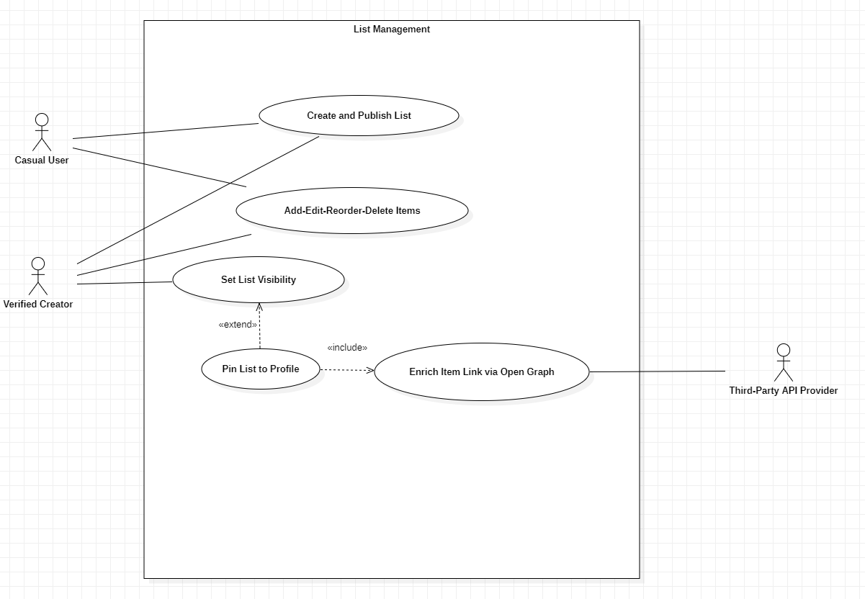
List Management:

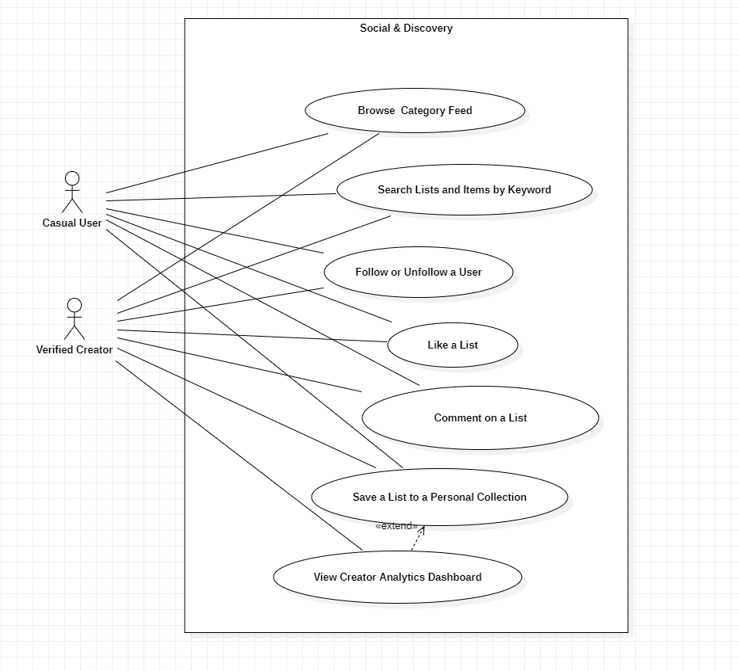
Social & Discovery:

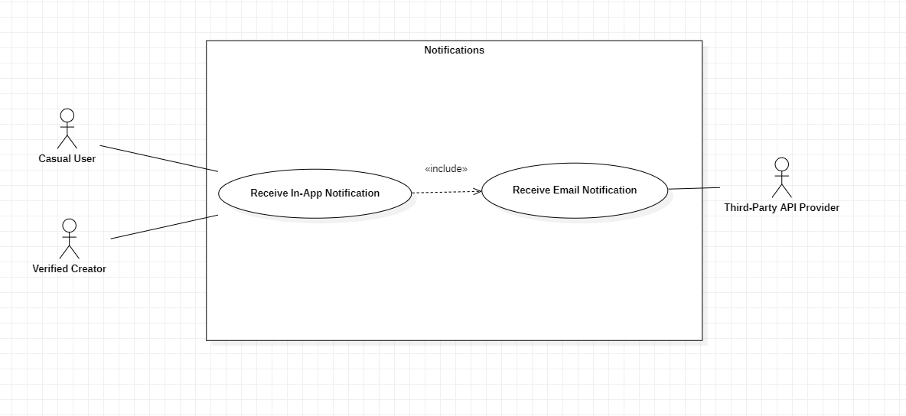
Notifications:

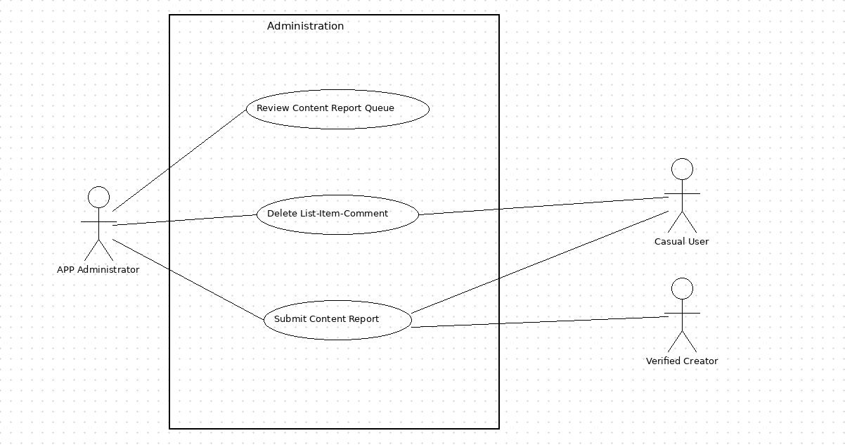
Administration:

